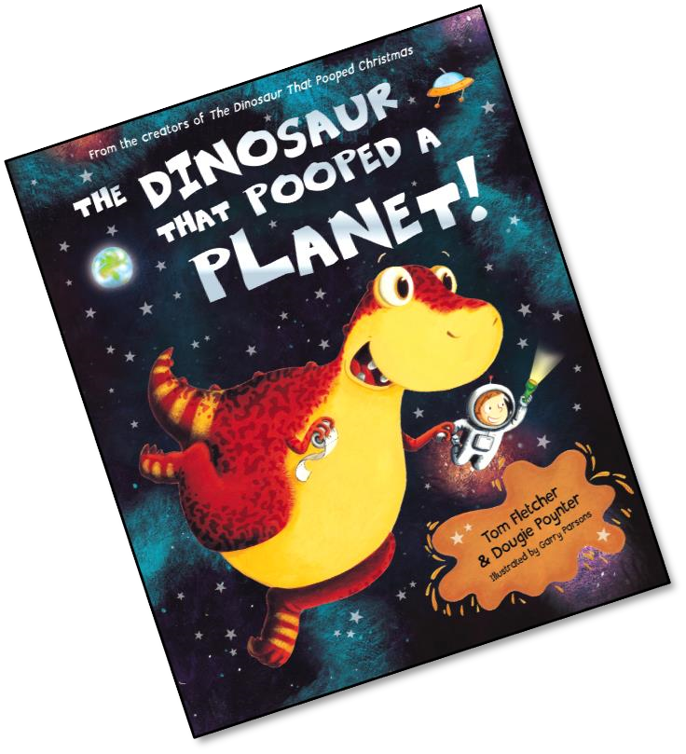
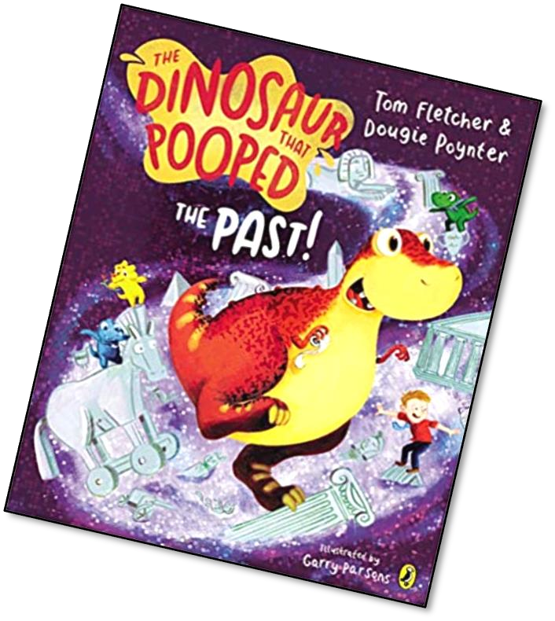
These activities and ideas are based around the books “The Dinosaur that Pooped a Planet” and “The Dinosaur that Pooped the Past”
By Tom Fletcher and
Dougie Poynter.
All activities could be done without the book!
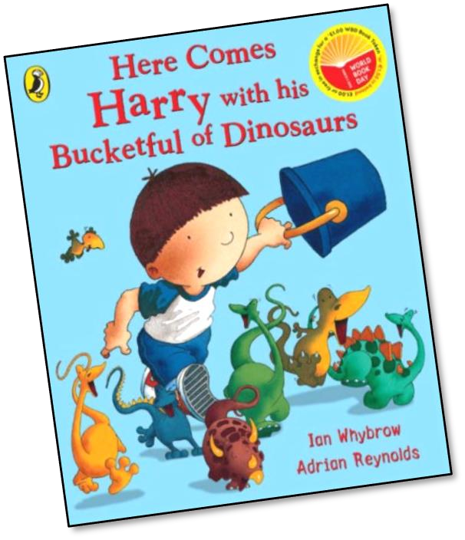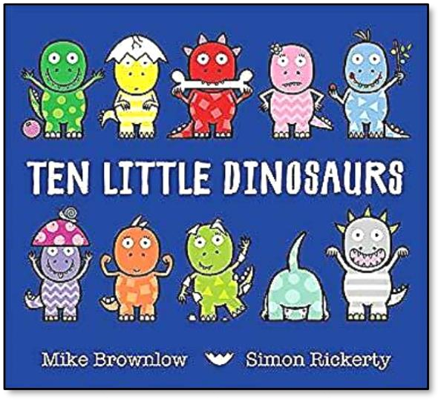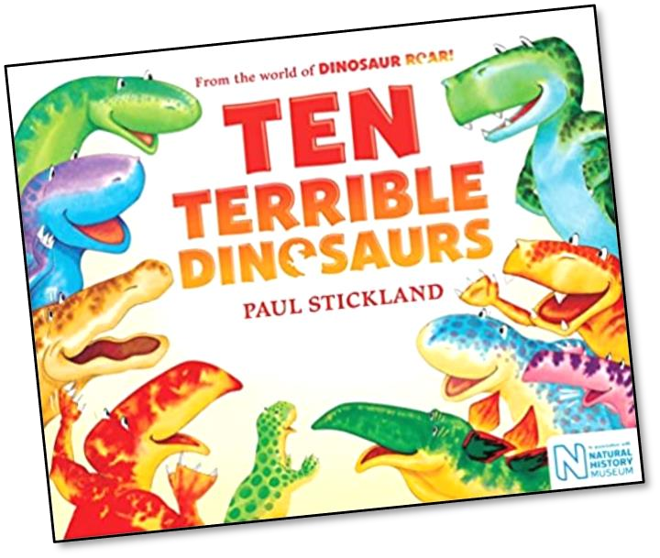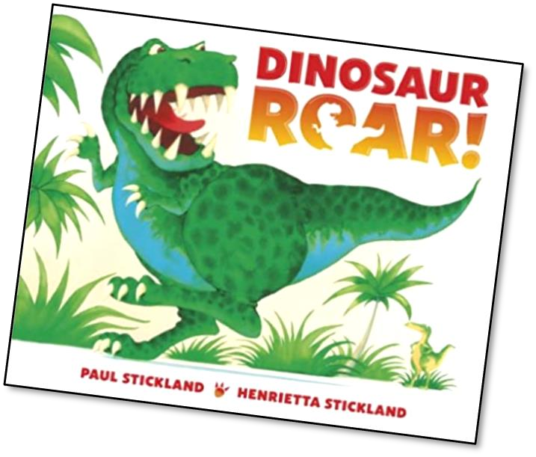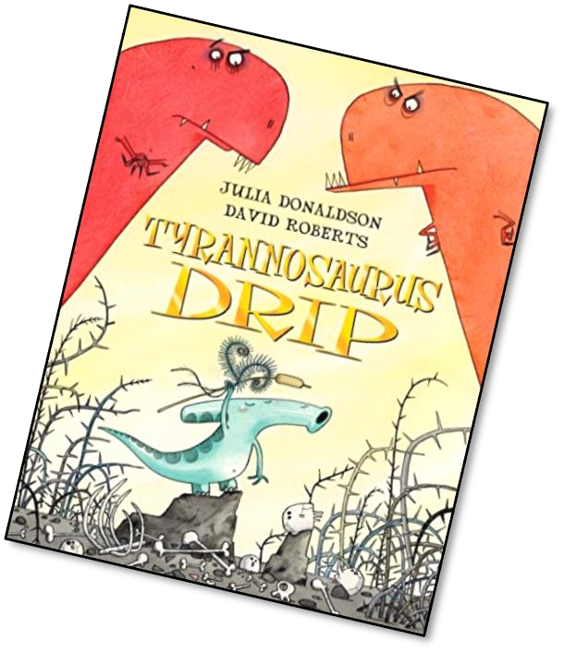
Other
stories
to read
and enjoy
with a
Dinosaur theme.
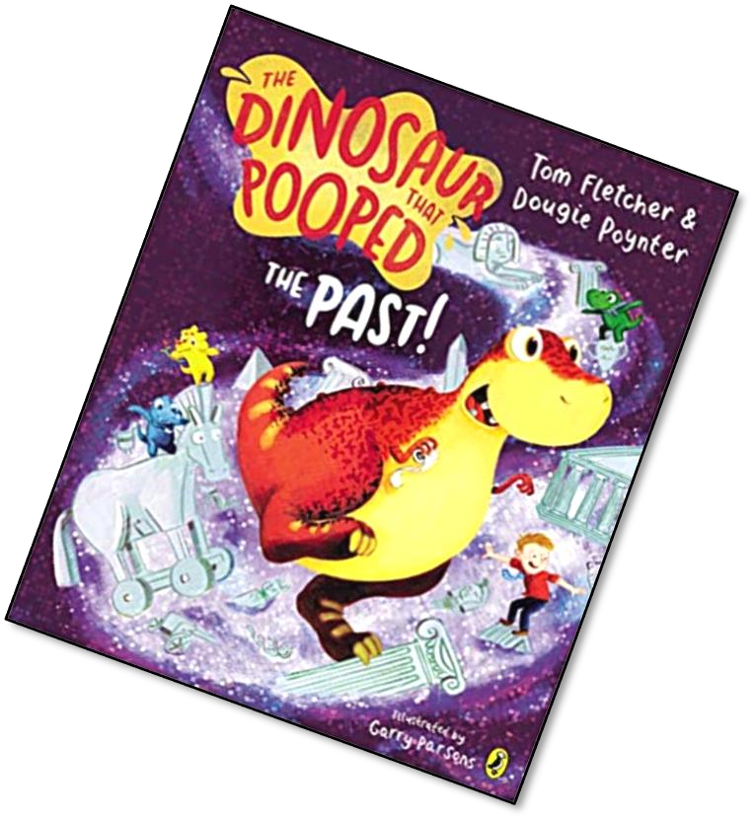
Off we Go!
First things first we need a rocket to help Danny and Dinosaur get into space.
Design your own space rocket and get ready for count down!
Talking Together
Gather things from around your house to make your own rocket.
Tubes, cups, cereal boxes and think about the shapes you would want to create. (You could use any objects around your house like before.) Danny has a lot of different shaped rockets to choose from!
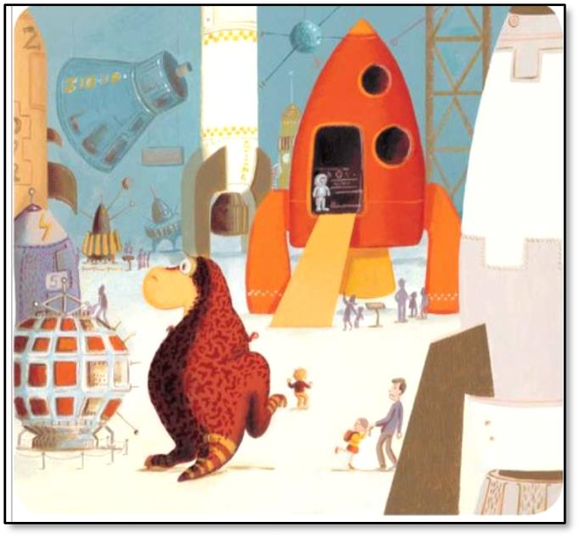
Create your own rocket command station!
Take a cardboard box or cereal box and design your buttons! What shapes will your buttons be? Will you have a big red circle one like Danny?
Remember to count down from 10 to blast off!
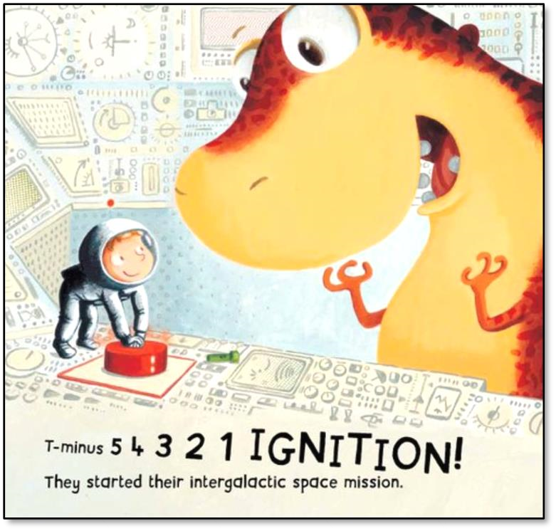
Reception
Danny’s Dinner
Danny forgets to take his dinner for him and Dinosaur!
Help Danny pack his lunchbox with some healthy choices so he doesn’t go hungry!
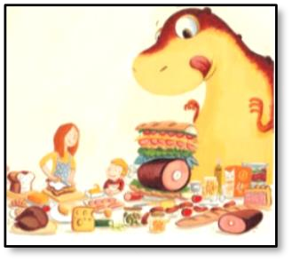
Lunchbox! Challenge
How many different combinations of healthy lunchboxes can you create for Danny?
Lunchbox! Challenge
What large amounts of food could you suggest to feed a Dinosaur?
Can you think of 10 things he could eat? (It doesn’t matter how silly!)
