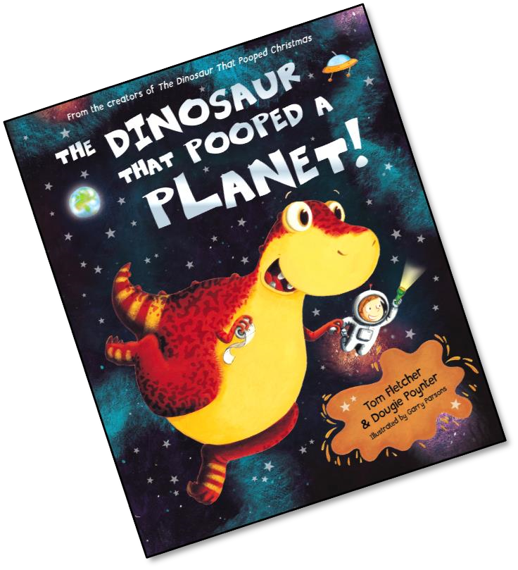
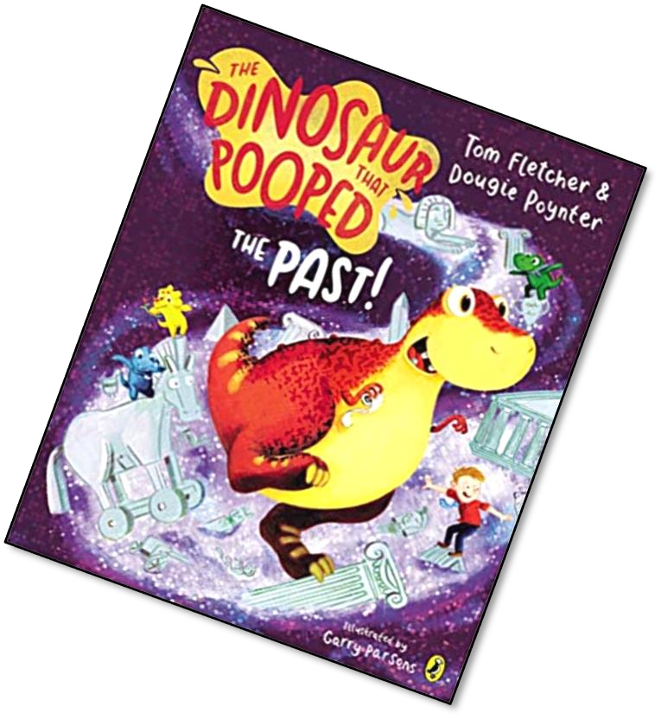
These activities and ideas are based around the books “The Dinosaur that Pooped a Planet” and “The Dinosaur that Pooped the Past”
By Tom Fletcher and
Dougie Poynter.
All activities could be done without the book!
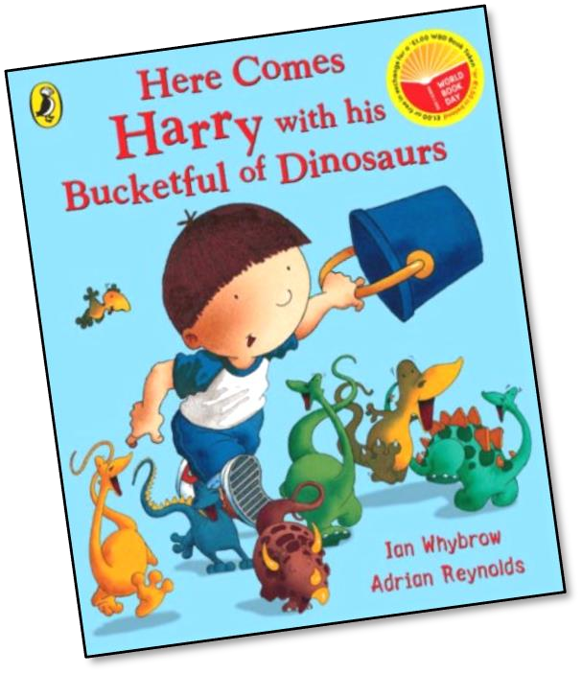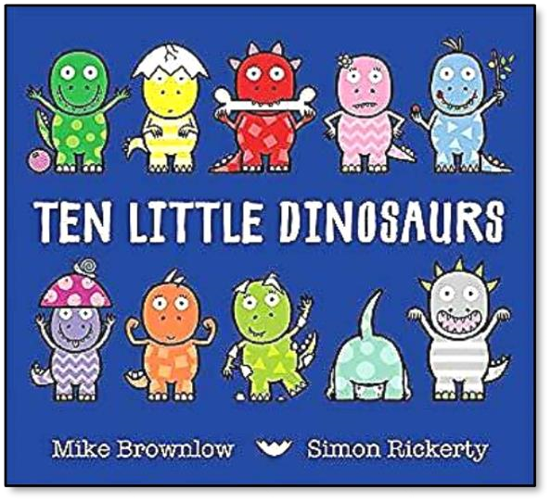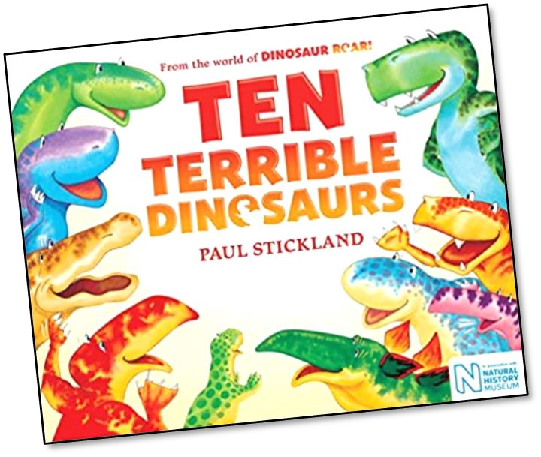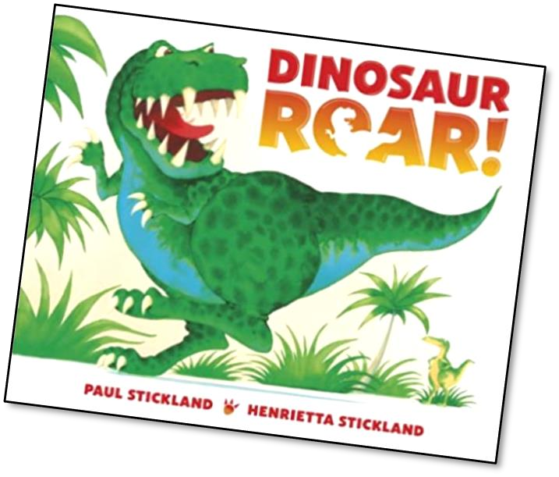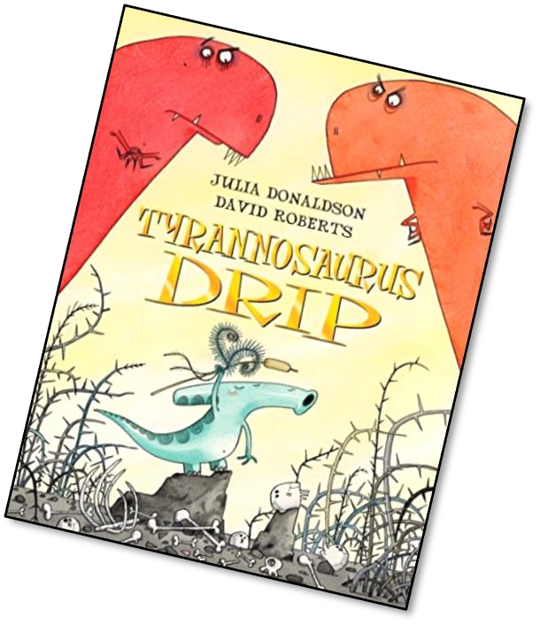
Other
stories
to read
and enjoy
with a
Dinosaur theme.
Dino Stacking!
In “The Dinosaur that Pooped the past” A, B and C get
themselves into all sorts of stacking patterns! Can you
arrange your 3 dinosaurs in 5 different ways?

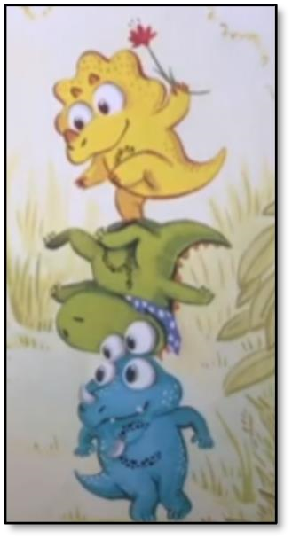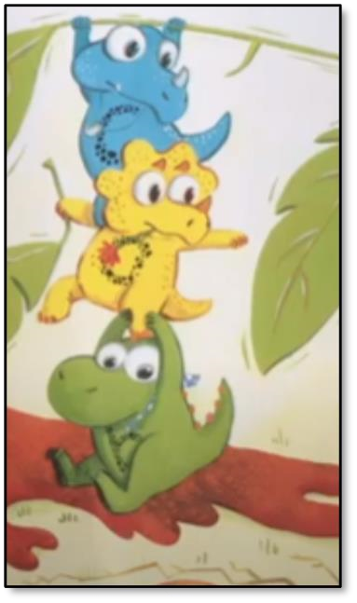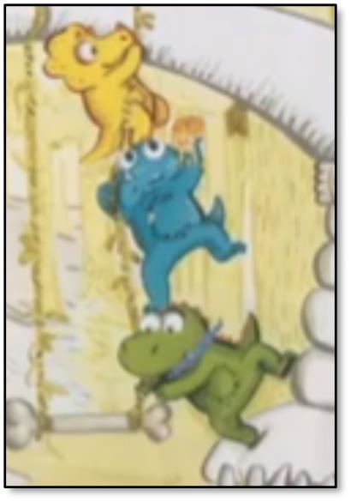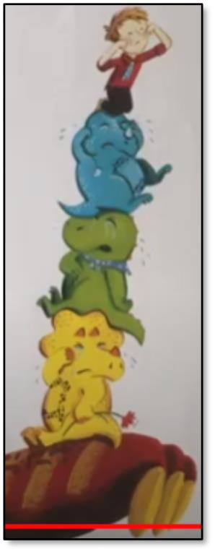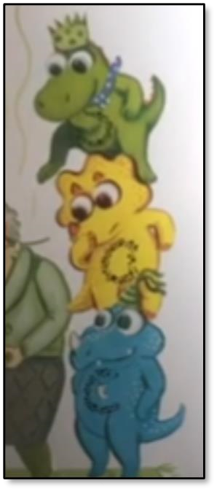

Can you make your shapes stack like the dinosaurs? Start with the first one. We have 3 colours.
Use the ABC dinosaurs to help you. Can you do another 4 different stacks?
Use the ABC dinosaurs to help you. Can you do another 3 different stacks?
Use the ABC dinosaurs to help you. Can you do another 2 different stacks?
Use the ABC dinosaurs to help you. Can you do one final different stack?
Create your own Dinosaur.
You will have developed a lot of pattern and shape skills by now. Create your own ABC
Dinosaurs or just one big one to poop a planet!
Make your own A, B and C Dinosaurs.
All you need is your hands and some paint! Dip your full hand in the paint and make your dino shape. Can you label your dino with how many scales, eyes, spots they have? Can you give your dinosaur a name?
