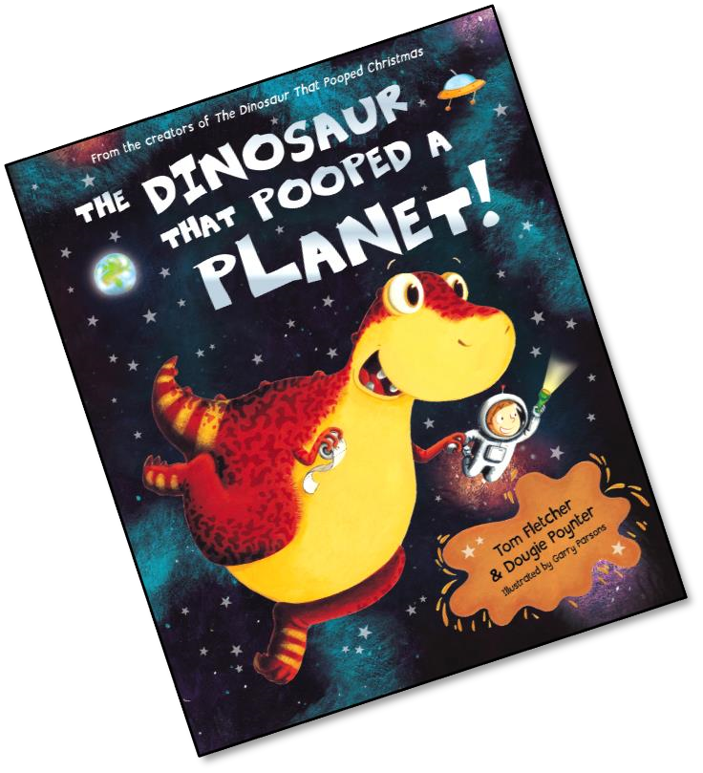
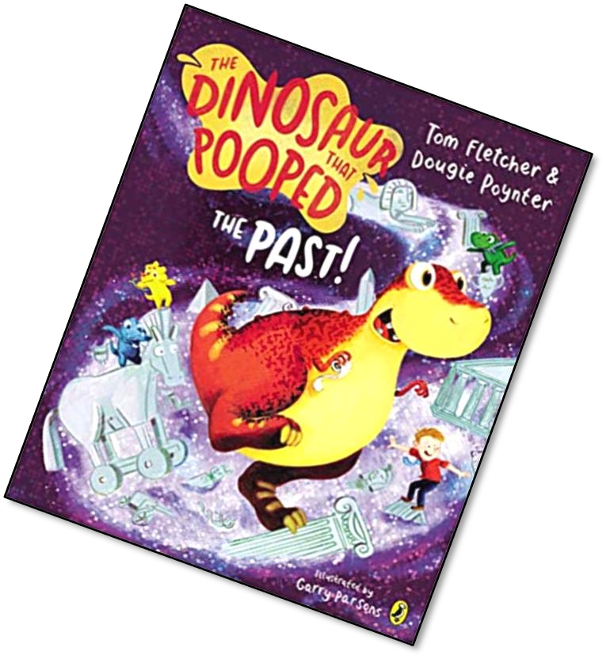
These activities and ideas are based around the books “The
Dinosaur that Pooped a Planet” and “The Dinosaur that
Pooped the Past”
By Tom Fletcher and
Dougie Poynter.
All activities could be done without the book!
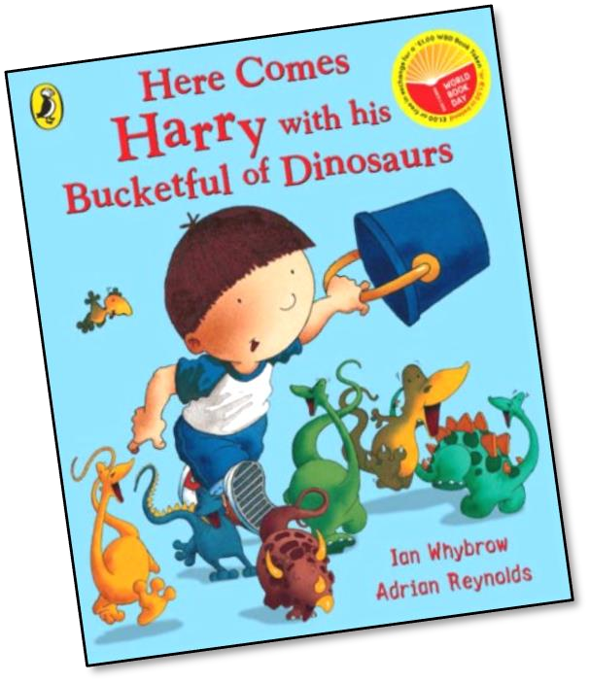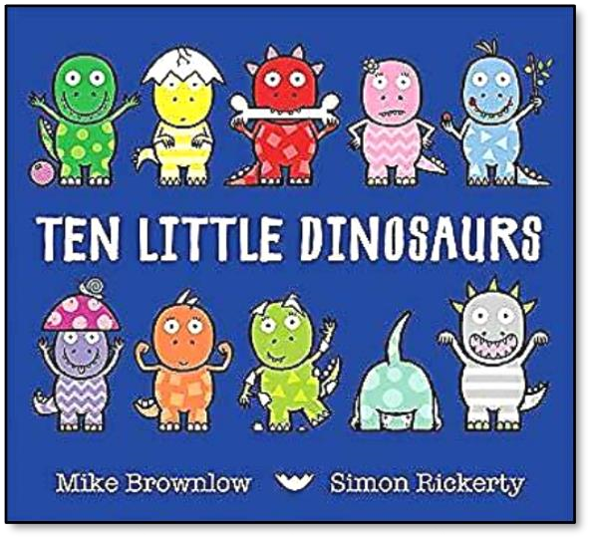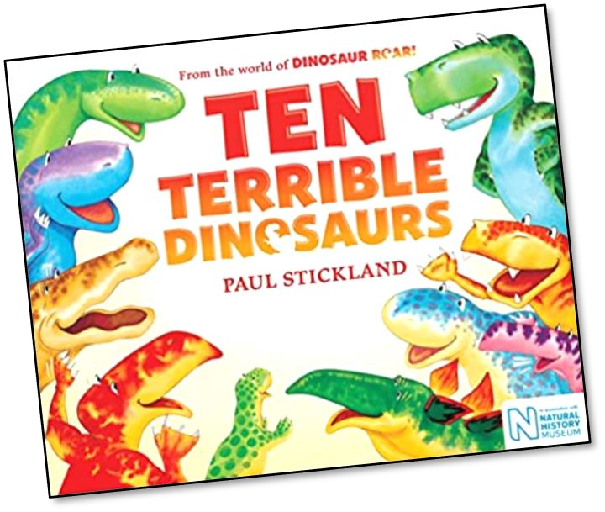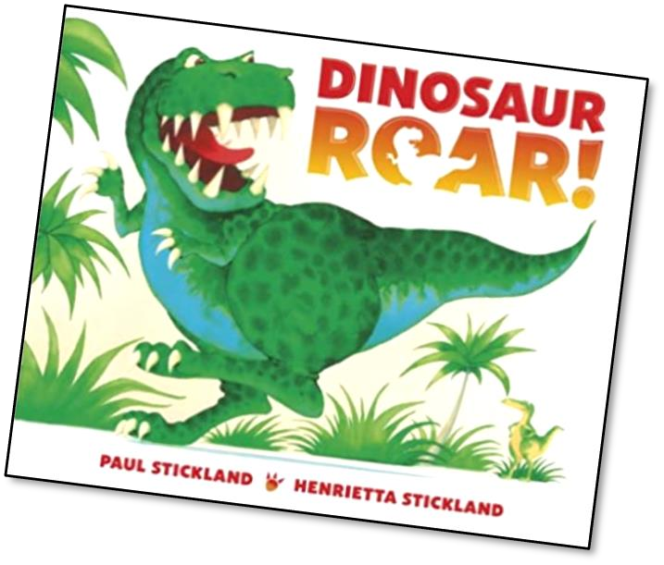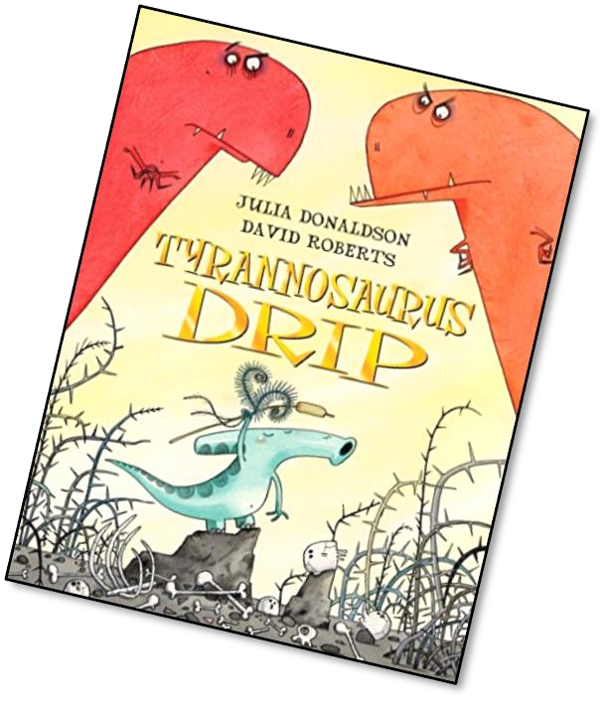
Other
stories
to read
and enjoy
with a
Dinosaur theme.
Reception
Rocket Doubles Game
Solve the double problems to make your
rocket and get all the parts ready to set off!
Talking Together
You will need 2 dice.
Roll the dice. See your double number.
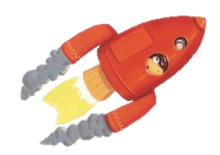
Look at which part of the rocket you can draw. The winner is the first person to draw a complete rocket.
You will need to roll a six to start.
(On either of your dice.)
Talking Together
Reception
Rocket Ride!
Danny’s friends have found out about his adventures into space. They want a rocket ride but which one to choose?

Talking Together
Danny’s friends want to go on a rocket ride. How many different ways can you share the children onto the 2 rockets? It doesn’t have to be a fair share!

Talking Together
Danny’s friends want to go on a rocket ride. How many different ways can you share the children onto the 3 rockets? It doesn’t have to be a fair share!

Talking Together
More friends want to go on a rocket ride. How many different ways can you share the children onto the 2 rockets? It doesn’t have to be a fair share!
have to be a fair share!
Talking Together
More friends want to go on a rocket ride. How many different ways can you share the children onto the 3 rockets? It doesn’t
Talking Together
More friends want to go on a rocket ride. How many different ways can you share the children onto the 2 rockets? It doesn’t have to be a fair share!
Talking Together
More friends want to go on a rocket ride. How many different ways can you share the children onto the 3 rockets? It doesn’t have to be a fair share!

