Nursery Rhyme Challenge! Can you tick each box once you have learnt the nursery rhyme and then completed the challenge?
Twinkle, Twinkle, Little Star  Use tin foil to make a star and then do a puppet show whist saying the rhyme. | I’m a Little Teapot  Make your parents a cup of tea (with adult supervision) and sing them the song while they sip. | Mary Had a Little Lamb  Make pompom lamb from white wool wrapped around two donut shaped pieces of card on top of one another. | Humpty Dumpty  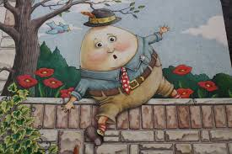  Help make a boiled egg and soldiers (strips of toast) replicating the characters in this rhyme. Sing as you wait for the egg to boil. | Hey Diddle Diddle  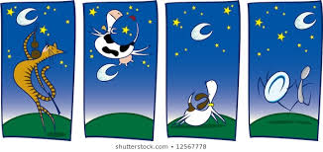  Can you act out this Nursery rhyme without saying the words to someone in your family and have them guess which one it is?
Baa Baa Black Sheep  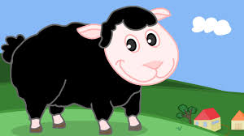  Use cotton wool and black pen/paint to create ‘bags of wool’ for each character. Role play as you say the rhyme. | One, Two, Three, Four  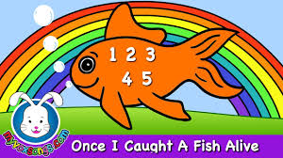  Fill a sink with some water or during bath time, put in a toy fish and try to catch it with a net/small sieve. | Hickory Dickory Dock  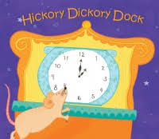  Find a clock in your house and name the numbers forwards, backwards and in a random order. | Polly Put the Kettle On  Have a tea time with a favourite teddy/doll and sing them the rhyme. | Pop! Goes the Weasel  Learn to make a ‘pop’ sound with your mouth and one finger that flicks out to the side. Say the rhyme and use the sound instead of the word.
Ring-a-ring o’roses  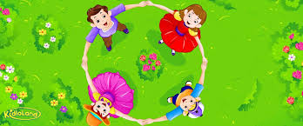  Do the actions to this rhyme with the people in your family. How fast can you go? | Jack and Jill  On your daily walk or just outside your house, can you hold a cup of water and walk for 10 seconds without spilling it all? | This Old Man  Can you sing and pat this rhyme out to the correct beat on your knees? | Round and Round the Garden  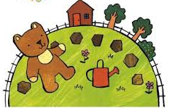  Use your teddy and do the actions with this rhyme. | Sing a Song of Sixpence  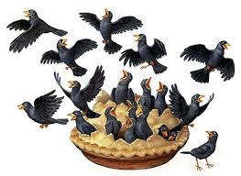  Make a small pie. You could choose fill it with blackberry jam and fruit.
This Little Piggy  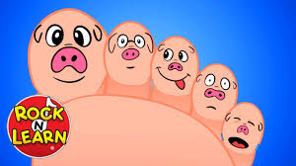  Can you do the actions to this rhyme on a parent without them laughing? | Little Miss Muffet  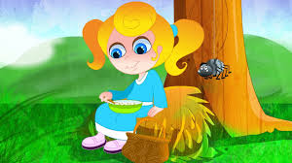  Act out this rhyme after you have found props around your house to your family audience. | A Sailor Went to Sea  Use a toy boat or make one with a recycling plastic pot and play with it during bath time whilst saying the rhyme. | B-I-N-G-O  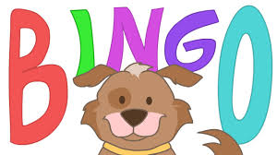  On your daily walk, every time you spot a dog sing the rhyme. | Here We Go Round the Mulberry Bush  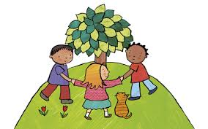  Say this rhyme with the matching actions with your family. Is there a bush or a tree on your walk that you could go around?
Incy Wincy Spider  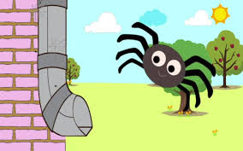  Make a spider puppet using paper, tape and string. Play with your new spider puppet and say the rhyme. | 5 Little Ducks  Perfect your quacking skills! Can you quack like Donald Duck? | Miss Polly Had a Dolly  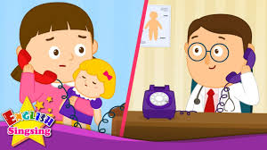  Use your dolly to role play this rhyme. Will you be Miss Polly or the doctor? | Old Macdonald Had a Farm  Sing this rhyme and leave out the animal names. Can your family guess what animal it is from the animal sounds that you make? | Row, Row, Row Your Boat  Sit in a box/cardboard delivery box and pretend it’s a boat as you say the rhyme. Use wooden spoons for oars.
Teddy Bear, Teddy Bear  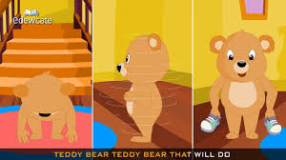  Say this rhyme and do the actions with your teddy. | Ten in a Bed  Can you find a collection of toys/teddies that amount to 10 and put them in your bed, rolling them off the bed as you say the rhyme. | The Old Grand Duke of York  Learn to march and practise on your daily walk. Make sure your knees lift up! | The Wheels on the Bus  Say this rhyme with the action and think of a new action/verse to add. | Wind the Bobbin Up  Use some wool or string and wind it around a pencil. Can you wind it forwards and then backwards?

