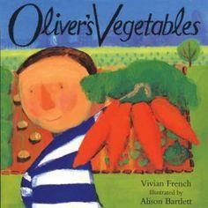
DAY 1

This week will be reading Oliver’s Vegetables, if you do not have this book at home I have added the link for you to find it online.
https://www.youtube.com/watch?v=2yvllKqyVUc

Activity:
Once you have listened to the story or read it again today at home, can you make your own peas in a pod?
Use a paper plate and scrunched up paper to make the peas and their pod.
Paint or decorate it with whatever art and crafts materials that you have at home.

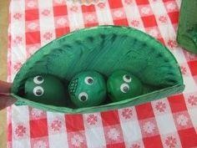

Day 2
Activity:
Your task is to find out everyone’s favourite fruit. You can use the sheet on here to find out or you can ask your family what their favourite fruit is and draw it in a bowl. What fruit is the most popular and which is the least? (Discuss what these words mean)

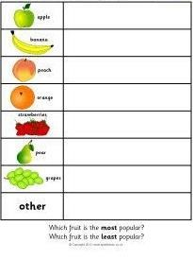

Day 3
Can you organise the fruits and vegetables below into their correct categories. If you are unable to print off the sheet you could discuss the fruit and vegetables on the sheet and even what you have in the kitchen at home.
What makes it a fruit? How do we know?
What makes it a vegetable? How do we know that?
What animals might eat certain fruits or vegetables?

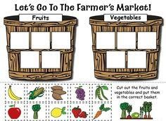

Day4
Today can you discuss with your children the plants below that you might eat at home or that are available to buy in the supermarket? Talk about what they look like, whether they have leaves, whether they grow in the ground or above the ground?
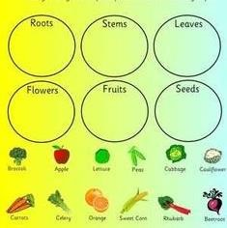
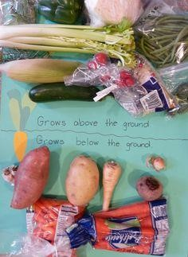

Day 5
Can you make your own shopping list?
Look in the fridge, the vegetable basket or wherever you keep your veggies.
Talk to your child what you will be cooking for dinner.
Can you think what vegetables you might need?
Write them down on a shopping list (you can write the first letter if you can hear it) or draw a picture.
