W/C 13/07/20 Spelling and handwriting practice – every day!
Please practice writing these words in cursive handwriting:
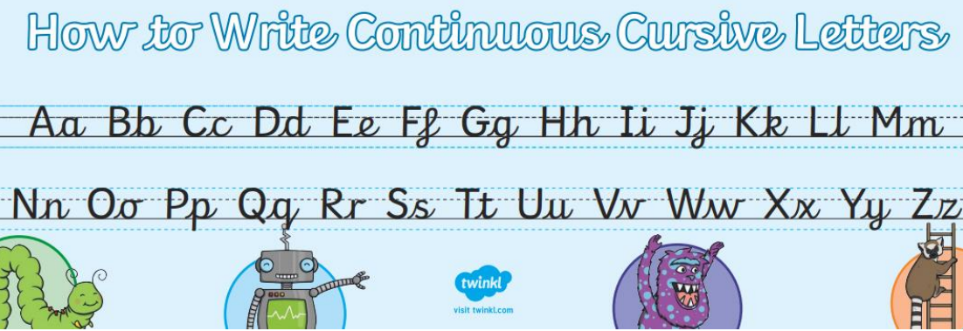
- Popular
- Position
- Possess
- Possession
- Possible
- Potatoes
- Pressure
- Probably

Bonus: write a sentence and a definition for each word.
On Friday, ask someone to test you. Check Class Dojo where your teacher will read out your spellings for you. Remember to send in your score!
Spelling words used in sentences:
- Chocolate is a popular choice of food.
- Are you in position to start the dance?
- I am going to possess some books to read over Summer!
- You must look after your possession carefully.
- It is possible that aliens exist!
- Roast potatoes are my favourite potatoes.
- If someone is bleeding, you should apply pressure.
- You are probably excited to return to school.

