**First Aid, Medical Conditions, Medication and Personal Care At**

**Harrington Hill Primary School**



REVIEWED: November 2020

NEXT REVIEW DATE: November 2021

Contents

First Aid Qualified staff 3

Definition of Medical Needs 4

Named Person 4

Partnership with Parents/Carers and Pupils 4

Absence as a Result of a Medical Condition 5

First Aid Bags and Boxes Locations 6

Recording of Accidents 7

Medication 8

Informing Parents 10

Clinic Waste Bin 11

Individual Health Care Plans 12

Response to an Emergency Involving a Child e.g.: Injury or Medication 13

If an Emergency Happens During Lesson Time 14

If an Emergency Happens During a Non-Teacher Directed Time 14

Procedure for Calling an Ambulance 15

Emergency Medication in School 19

All emergency medication in school is considered as spare or back up devices and not a replacement for the pupil’s own medication. 19

Asthma 21

How to Deal with an Asthma Attack 22

Extended School 23

Diabetes 24

Hypo Signs and Symptoms – A Children’s Guide 25

Epilepsy 26

Toileting Incidents 28

Infection Control 29

Addendum for Covid-19 Protocols 31

***Striving for Excellence. Achieving Together.***

*Striving for excellence. Inspiring to achieve collaboratively through respect, happiness and creativity.*

*We are independent and reflective for continuous improvement.*

In accordance with ***The Children and Families Act 2014****,* Harrington Hill School is committed to providing pupils with a high quality education whatever their medical need, disability or individual circumstances. We believe that all pupils should have access to as much education as their particular medical condition allows so that they maintain the momentum of their learning whether they are attending school or going through periods of treatment and recuperation. We promote inclusion and will make all reasonable adjustments to ensure that children and young people with a medical need or Special Educational Needs or Disabilities (SEND) are not discriminated against or treated less favourably than other pupils.

# First Aid Qualified staff

|  |  |  |  |  |
| --- | --- | --- | --- | --- |
| Forename | Surname | Qualification | Start | End * |
| Aysu | Ozdemir | First Aid at Work | 5th July 2017 | 4th July 2020 |
| Farzana | Patel | First Aid at Work | 5th July 2017 | 4th July 2020 |
| Ruta | Strazdaukaite | First Aid at Work | 5th July 2017 | 4th July 2020 |
| Jade | Eames | Paediatric  First Aid | 19th July 2017 | 18th July 2020 |
| Rhonda | Samuels | Paediatric  First Aid | 19th July 2017 | 18th July 2020 |
| Bukurije | Haxhijaha | Paediatric  First Aid | 19th July 2017 | 18th July 2020 |

*End date extended until 31st Dec 2020 due to COVID

# Definition of Medical Needs

A person has a disability if he or she has a physical or mental impairment that has a substantial and long-term adverse effect on his or her ability to carry out normal day-to-day activities.

For the purpose of this policy, pupils with medical needs may be:

* pupils with chronic or short-term medical conditions or a disability involving specific access needs, treatments, support or forms of supervision during the course of the school day, or
* sick children, including those who are physically ill or injured or are recovering from medical interventions, or
* children with mental health problems.

# Named Person

The members of staff responsible for ensuring that pupils with medical needs have proper access to education is **Hester Enthoven**, the Special Educational Needs Coordinator (SENCO) and **Elaine Vuong**, the Medical Officer. Elaine will be the person with whom parents/carers will discuss particular arrangements to be made in connection with the medical needs of a pupil. It will be her responsibility to pass on information to the relevant members of staff. This person will liaise with other agencies and professionals, as well as parents/carers, to ensure good communication and effective sharing of information. This will enhance pupils’ inclusion in the life of the School and enable optimum opportunities for educational progress and achievement.

# Partnership with Parents/Carers and Pupils

Parents hold key information and knowledge and have a crucial role to play. Both parents and pupils will be involved in the process of making decisions.

* Parents are asked to keep the school informed about any changes in the treatment their children are receiving, including changes in medication.
* Parents will be kept informed about arrangements in school and about contacts made with outside agencies.
* Parents and pupils will be consulted before referral to the Home Tuition Service

# Absence as a Result of a Medical Condition

* All parents are expected to inform the school on the first day that their child is absent. If an absence lasts for a full week or longer, parents must produce a medical certificate.
* In cases where pupils are absent for periods less than 10 working days, parents will follow the normal arrangements for informing the School. If the length of the period of absence can be anticipated, then it may be appropriate for the school to provide the pupil with work to do at home.
* Where an absence exceeds 10 working days, the School will inform the Education Attendance Service. Parents will need to provide the School with a letter from a medical consultant containing details of the medical condition or intervention and information about the estimated period of absence.
* If a pupil is to be admitted to hospital for a period longer than 5 working days, then the SENCO will contact the Hospital School and will consult with staff there about ensuring continuity of education.

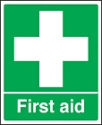**The Medical Room**

**The medical room is to only be used when a child is accompanied by an adult.**

A TA will need to accompany a child to the room and treat the child as necessary, this includes ***supervising and recording*** the taking of medication.

If you do not have a TA in your room, use the TA for your year group, if not possible send a message to the office.

**Never send an unwell child to the office! Keep the child in class supervised and send a message to the office.**

# http://t3.gstatic.com/images?q=tbn:ANd9GcSNBK389K1k5_P8XKb-O5QnUWU6OOgFcqkrwOpV7cH78wbGGUtI8Q:www.safelincs.co.uk/shopimages/products/high/Motorists-Standard-First-Aid-kit.jpgFirst Aid Bags and Boxes Locations

Lower teaching level

* Medical room
* EYFS
* Kitchenette

Upper teaching area

* Medical stations

There are also 7 bags for taking out of school, these are kept in the medical room and need to be signed out along with any medications you need for pupils. Sign the bag back in making a note of equipment used and date returned. ***Care Plans MUST*** be taken when leaving the school site.

You must all record all accidents on Medical Tracker at the time of the incident. Details of how to complete this is found on page 7 of this booklet.

The first aid bag contains orange bags for soiled dressings, orange bags MUST go in the orange bin in the medical room at school! It is illegal for orange bags to go into household waste.

# Recording of Accidents

All first aid and illness visits to the medical room should be logged onto Medical Tracker. To do this complete the following step:

1. Login to your Medical Tracker account
2. Click on the Incidents tab
3. Click on the new button and select the incident. The following form will appear.

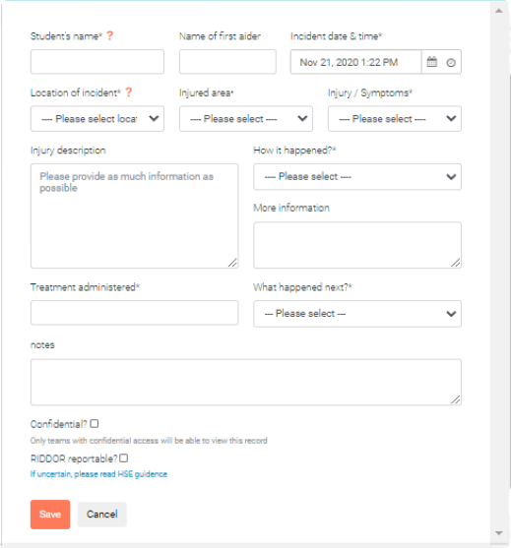

1. Type the name of the child in the Student Name box
2. Complete as much information as possible. Write a brief description of the incident, do NOT use any other names of children.
3. Press save.

The log is vitally important and must be completed in full, include; what, where and how the accident happened. Everything you do with the casualty MUST be noted, if it is not logged, it did not happen.

# C:\Users\EVuong\AppData\Local\Microsoft\Windows\INetCache\Content.MSO\41F2D2DF.tmpMedication

Staff should NEVER accept medication or medical information from parents or children at the classroom door or in the playground.

Parents must take the medication to the office and complete a medication administration form; the office will then pass this to the medical officer who checks the medication against the form, arranges copies of the form to the medical room and stores the medication appropriately.

All medical information should be reported to the office so the information can be held and shared appropriately and in line with the schools data protection and GDPR policies.

If there is no completed medication’s form we cannot give the medication

This is to protect children and staff!

If a child has taken any medication complete the following steps on Medical Tracker:

1. Click on Medication Use
2. Select New and complete the following form in as much detail as possible

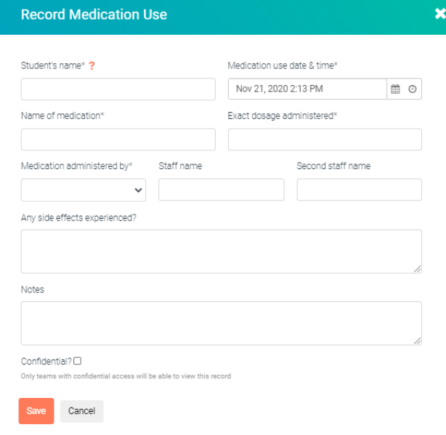

1. If a child has a Medical Condition, you can see the list of them appear, and selecting the Apply button will fill the form in for you.

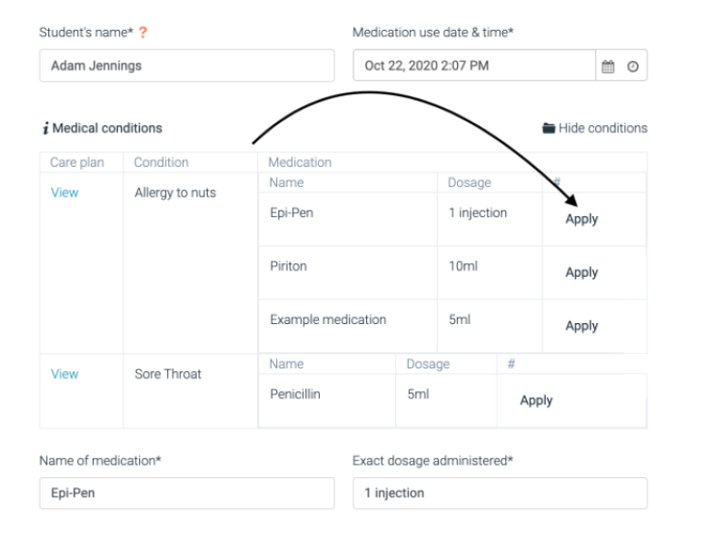

1. Press Save

# Informing Parents

When logging an incident/illness or medical use you must send an email ***immediately.***

To do this, complete the following steps:

1. Find the incident or medical use you want to select
2. Select Send Notification

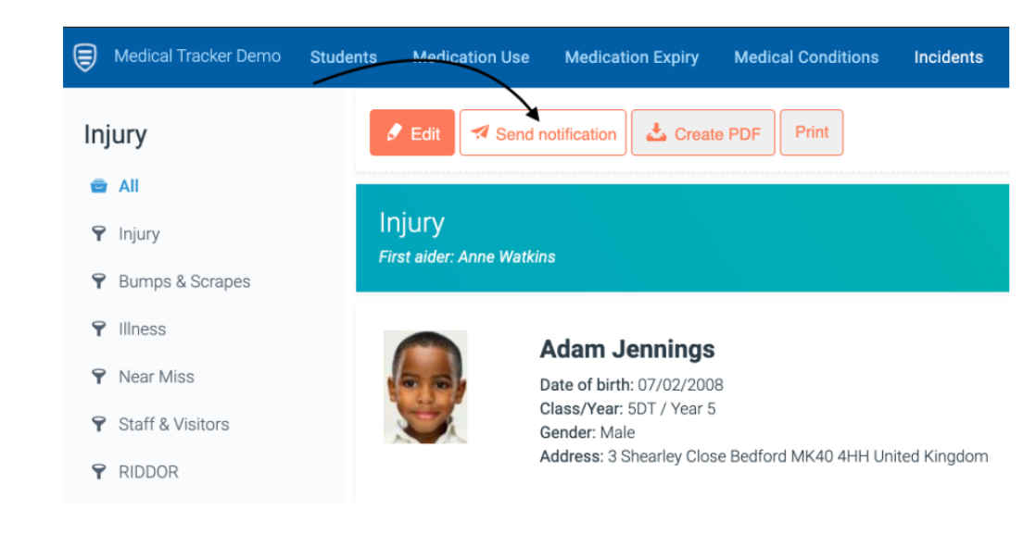

1. Press Parental/Carer Notification
2. Select Email Message. You will then see a view that will enable you to select the email address for the parent you want to send the notification to

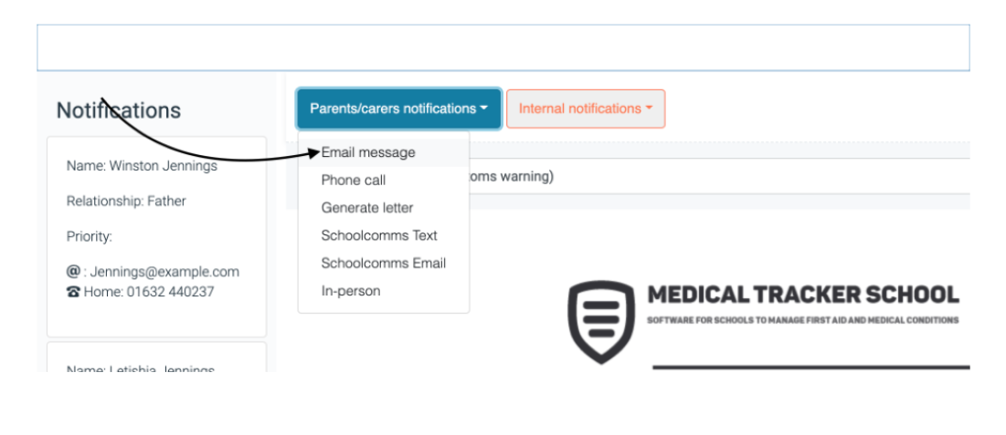

1. Press Done and the email will be sent

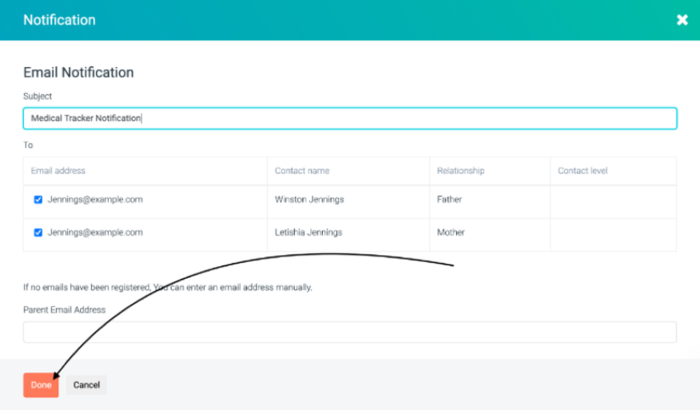

Inform the office when requesting a child be sent home, giving a brief explanation why they are to go home.

*Staff should send an email when emergency medication is used such as a reliever inhaler. (Used outside of prescribed timings, E.G. when having an asthma attack)*

*When a technical issue with Medical Tracker staff then ask the office to call and inform the parent. Give the office as much information as possible.*

# Plastic pedal binClinic Waste Bin

There are three types of bin in the medical room

* Clinical waste is sent for incineration

Anything which comes into contact with the casualty should go into the clinical waste bin, such as

* Gloves worn to treat a casualty
* Used swabs
* Used disposable ice packs
* Disposable linen
* House hold waste

For paper towels and wrappers of plasters and dressing packs.

# Medical Clipboard Stock Illustrations – 11,194 Medical Clipboard Stock Illustrations, Vectors & Clipart - DreamstimeIndividual Health Care Plans

Some children in school will require an individual health care plan to assist everyone in managing that child’s individual need.

It sets out

* The condition and its effects
* Triggers
* Treatment including emergency procedures.

The health care plan should be kept in the Medical Room, a copy should also be in each class’ Additional Needs Folders in classrooms and on Medical Tracker.

***The HCP should go with the child on any outing or off site activity along with their medication.***

All staff working with that child should be aware of the plan and how to implement any emergency procedures.

# personnel | First Aid Kit | Clipart Panda - Free Clipart ImagesResponse to an Emergency Involving a Child e.g.: Injury or Medication

1. Do not panic

Stay calm

Take a few deep breaths

1. Reassure the pupil

Check a watch or a clock. Note the time the incident happened/began

1. Is there any immediate danger?

If so, do what you can

1. Is there another adult nearby?

Shout for help or send a child with a message to the office for help.

1. What do you need to do to ensure the safety of the pupil/other pupils?

*Do not move the pupil* unless specific instructions indicate otherwise or s/he is in danger.

Ensure pupils do not gather around the pupil involved in an emergency

1. Follow any guidelines or care plans for such situations. These may be set in motion by your message.
2. Ask colleagues to remove other pupils from the immediate vicinity.

# If an Emergency Happens During Lesson Time

1. The teacher will calmly reassure ALL the pupils
2. They will assess the situation and inform the designated person immediately using the above procedure.
3. Follow the above guidelines
4. Once there is an adult to take responsibility for the pupil the teacher should remove the rest of the class from the teaching area.

# If an Emergency Happens During a Non-Teacher Directed Time

1. The adult will calmly reassure ALL pupils nearby
2. Follow the above guidelines

The privacy and dignity of the child/adult will be respected in all situations

Issues regarding confidentiality will be observed by all adults involved

# Procedure for Calling an Ambulance

* Should an ambulance be required the *first aider in attendance should make the call themselves* ambulance control ask a series of questions about the casualty and the adult needs to be with them to answer these questions fully.
* Once an ambulance has been called **YOU** must inform the office so that staff can be sent to the school gates ready to meet the crew and direct them to the incident.
* The office will also call the parent to arrange for them to meet the ambulance
* The office arrange for a print out of the child’s details for the ambulance crew. The first aider will need to hand over care to the attending crew.
* Please let the office know if you feel you may need someone to interpret, so they can find a member of staff.

1. Dial 999
2. Ask for Ambulance
3. Be ready with the following information

* School telephone number 0208 806 7275
* School address Harrington Hill School, Mount Pleasant Lane, London E5 9JG
* Location within the school where the incident is
* Brief description of the symptoms and any known medical conditions

C:\Documents and Settings\jbarber\Local Settings\Temporary Internet Files\Content.IE5\RVI9FAWW\MC900312730[1].wmf

* Inform ambulance control of the best entrance and state that the crew will be met at this entrance and taken to the pupil
* Don’t hang up until the information has been repeated back to you.
* Speak clearly and slowly

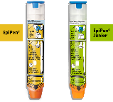**Epi-pens**

If a child in your class has a severe allergic reaction to a food etc. their epi-pen is kept in the medical room. *When any activity takes place in the class room involving food the epi-pens (2) should be taken into the class room, after the session the medication is immediately returned to the medical room.* All staff working in the year group must be informed about the child’s medication, cause, symptoms to look out for and how to administer the medication.

Remember it is important to make sure the auto-injector is within its expiry dates.

ADMINISTER EPI-PEN AUTO-INJECTOR THEN IMMEDIATELY DIAL 999 AND SAY ANAPHYLAXIS

Allergic reaction

* Skin redness
* Itchy skin
* Tingling and swelling of hands/feet/eyelids/mouth/lips/genitals
* Red, itchy eyes
* Itchy mouth and/or ears
* Nausea, vomiting, stomach pain
* Heart palpitations
* Light-headedness

Anaphylaxis

* Tightening of the throat/difficulty breathing
* Collapse/loss of consciousness
* Sense of impending doom

Causes can include: Nuts, fish, dairy products, eggs, fruit, wasp/bee stings, natural latex and many others.

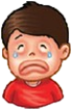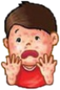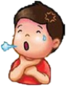

Tightening of throat / Difficulty in breathing

Itching/Rash

Tingling and swelling of lips/eyes/face

**Allergic reaction - give oral antihistamine**

**Anaphylaxis – Give Adrenaline Auto-Injector followed by Antihistamine when possible.**

* Any one suffering from anaphylaxis should not move around, the medication should come to them, not the other way around.
* **Administer second EpiPen dose after 5-15 minutes if patient does not respond or original symptoms return** once the second dose is given you should make a second call to the emergency services to confirm that an ambulance has been dispatched.

Remember: When you call an ambulance the child’s medication and care plans should go to hospital with the child.

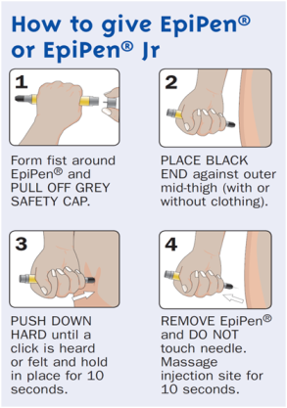

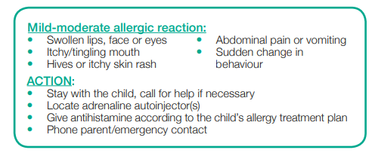

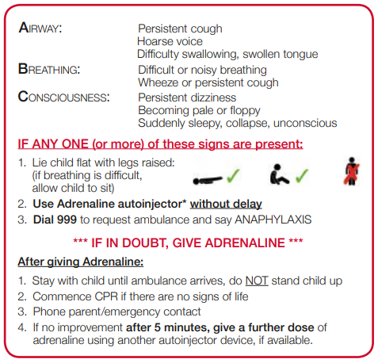

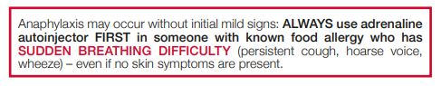

# Emergency Medication in School

# All emergency medication in school is considered as spare or back up devices and not a replacement for the pupil’s own medication.

School staff may administer ‘spare’ emergency medication (AAI or Salbutamol inhaler) without prescription for use in emergencies, but only to a pupil at risk of anaphylaxis/Asthma attack, where both medical authorisation and written parental consent for use of the spare has been provided.

These medications will only be administered to pupils whose own medication cannot be administered correctly without delay.

When administering ‘spare’ medication, staff must still follow the set procedures for anaphylaxis/severe asthma, the medication is not intended to replace prompt professional medical intervention.

Only staff trained in the use of emergency medication should assess, administer and record use of these medications.

**Adrenaline auto-injectors (AAI)**

Any one suffering from anaphylaxis should not move around, the medication should come to them, not the other way around.

If a pupil has been administered the ‘spare’ AAI an ambulance must be called and the used medication should be handed to the paramedics on arrival with a full hand over and the pupil’s care plan.

If a second dose is given you should make a second call to the emergency services to confirm that an ambulance has been dispatched.

The appointed person is responsible for monthly checks on the medication and ensuring that it is maintained, including updating the register and it is available should it be required.

Yearly training will be provided to staff to ensure they have the knowledge and skills required to ensure effective, safe and prompt treatment for anyone in anaphylactic shock.

**Salbutamol Inhalers**

The ‘spare’ inhaler should only be used by children:

* Who have been diagnosed with asthma, and prescribed a reliever inhaler
* OR who have been prescribed a reliever inhaler

***A child may be prescribed an inhaler for their asthma which contains an alternative reliever medication to salbutamol (such as terbutaline). The salbutamol inhaler should still be used by these children if their own inhaler is not accessible – it will still help to relieve their symptoms and could save their life.***

Staff will ensure that should the ‘spare’ inhaler be used that the correct procedure is followed and ensure that the plastic inhaler is washed after use.

If using the ‘spare’ inhaler staff will prime it (spray two puffs) before use.

If the ‘spare’ inhaler is contaminated with blood it will be disposed of and a replacement arranged. Any contaminated inhaler cannot be re-used owing to the risk of cross contamination.

The school will ensure that out of date or empty ‘spare’ inhalers are returned to be recycled appropriately.

The appointed person will ensure the medication is stored correctly checked monthly and primed (spray two puffs) to prevent blockage when not used. They are also responsible for monthly checks on the medication and ensuring that it is maintained, including updating the register and it is available should it be required.

Yearly training will be provided to staff to ensure they have the knowledge and skills required to ensure effective, safe and prompt treatment for anyone suffering from an asthma attack

# Asthma

Each person with Asthma will have a different trigger; here are some common triggers;

* Colds or flu
* Tobacco smoke
* Exercise
* Allergies to things like pollen, furry or feathery animals or house-dust mites.

The most effective way of taking most asthma treatments is to inhale the medicine, through a spacer, so it gets straight into your lungs.

There are two main types of asthma medicine which are equally important but do different things. They are called relievers and preventers. Preventers are usually brown and used at home.

Reliever inhalers are usually blue and you take them when you have symptoms (like wheeze or cough). They work quickly by relaxing the muscles surrounding the narrowed airways making it easier to breathe. Reliever inhalers are essential in treating asthma attacks.

**Handy hints for using a spacer**

* Make sure that the spacer you have been given fits your inhaler
* Put one puff of your inhaler into the spacer and breathe in deeply through the mouthpiece.
* Hold your breath for ten seconds (or for as long as is comfortable) then breathe out slowly. It is best to take at least two deeply held breaths for each puff of your inhaler.
* If you find it difficult to take deep breaths, breathing in and out of the mouthpiece several times is just as good.
* Repeat the step above for each dose/puff needed
* Wash your spacer once a month (TAs to do this) - leave it to drip-dry as this helps to prevent the medicines sticking to the sides
* Using metal or anti-static spacers can help to make sure that most of the medicine gets into your lungs
* Spacers should be replaced at least every year, especially if you use them daily

For more information on how to use a specific inhaler and spacer visit [www.asthmauk./how](http://www.asthmauk./how) to use your inhaler

How to Deal with an Asthma Attack

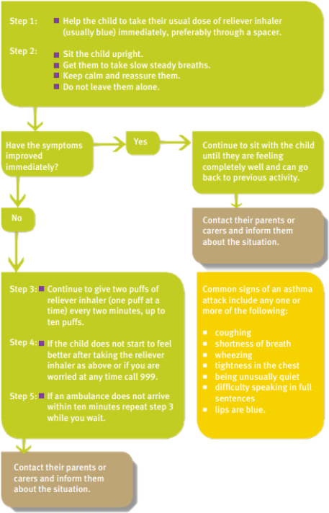

# Extended School

Wrap around provision is provided at Harrington Hill Primary School by Nation Sports. Parents and carers must note their child’s medical needs on the admissions form and ensure that the Nation Sports’ staff have any necessary medication for their child.



# Diabetes

A child with diabetes will require testing of their blood glucose (BM) this is usually done in the medical room owing to the use of needles (sharps). There would be guidance in the medical folder or Individual Health Care Plan regarding insulin dosage.

When a child is taking insulin adults are required to check that the correct dose is being delivered.

Training and support will be given to staff that assists a child managing their diabetes. The training should include how to manage the condition, what to do in an emergency, safe storage of equipment, medication, sharps procedures, protocols and their safe disposal.

There will also be support for trips and activities off site.

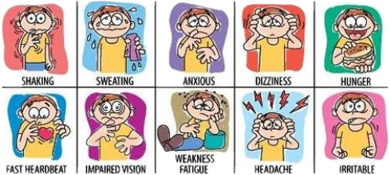

# Hypo Signs and Symptoms – A Children’s Guide

A hypo happens when your blood sugar level drops too low (under 4.0 mmols/l on your blood glucose meter). Read this with your parents so you know what the signs of a hypo are.

You may feel one or more of the following hypo signs:

* Feeling tired
* Suddenly feeling either hot or cold for no real reason
* Feeling very hungry
* Having a headache

http://x.bidswitch.net/sync?ssp=switchconceptshttp://match.adsrvr.org/track/cmf/generic?ttd_pid=switchconceptsFeeling sick

* A tingling feeling in your hands, lips or tongue
* Not being able to think or talk properly
* Feeling weak and finding it harder to move than usual
* Not feeling in a good mood

**Treating hypos**

If you feel low on sugar, have something sugary to eat, such as:

* 3 or 4 glucose tablets
* Some sweets
* A few sugar lumps

You can have a sugary drink but it’s easy to drink too much when low so it’s often best to stick to sweets and sugar.

Unless you have a hypo just before a meal, it’s worth having a little bit of longer acting carbs to stop you going low later on. Longer acting carbs could include crackers or a piece of fruit. **Hypos can happen to people with type 1 or**[**type 2 diabetes**](http://www.diabetes.co.uk/kids/type-2-diabetes-and-children.html)**.**

**Low or high?** You may also feel some of the hypo signs when you have high sugar levels as well, so if you feel well enough to, it’s worth doing a blood test to see what your sugar levels are.

**After a hypo**

After some time has passed since the hypo you may need to test your sugar levels to see how your sugar levels are.

# Epilepsy

Epilepsy is a disorder of the brain in which there is a tendency to have recurring seizures. The fact that seizures can reoccur is key, as a one off seizure does not mean it is epilepsy.

***It can affect anyone, at any age, from any walk of life.***

An epileptic seizure results from a sudden electrical discharge in the brain that causes changes in sensation, behaviour or consciousness. Seizures can take many forms because the brain is responsible for such a wide range of functions. Seizure symptoms depend on where in the brain this abnormal burst of electrical activity happens. As a result, there are many different types of seizures - most usually last from a few seconds to a few minutes and usually stop without any treatment.

If a child in your class has Epilepsy, their care plan will specify the particular set of actions required; specific to their individual needs, the following is a guide to good practice. Emergency medication should be accessible at all times, this may mean having to carry the medication to the PE space, assembly area, or library etc.

School will ensure that staff are epilepsy aware and know what to do should an emergency occur. This training, usually provided by the school nurse in liaison with the parents and other health professionals (with parent’s permission) will share appropriate information about the pupil’s education, healthcare, medication and any affects this has on their school life (for example epilepsy medication and seizures can affect a person’s ability to concentrate)

Staff may be required to maintain records of changes in behaviour when witnessing a seizure and/or description charts and emergency medication use, this is so that seizure patterns can be identified and so that this information can be shared with the pupil’s parents and healthcare team. Staff will ensure that the pupil is supported during and following a seizure.

General good practice requires that two members of first aid staff would be in attendance for a child experiencing a seizure;

* First aider one, to give first aid and care to the person
* Second to manage the scene, organising medication, making the area safe, and screening from anyone else in the vicinity. The second person will be able to use the monitoring sheet and call for an ambulance if and when required, alongside supporting and giving emergency first aid in addition to assisting with any deterioration of condition.

**When you witness a potential seizure**

**As the second responsible adult**

# Toilet Cartoon Stock Illustrations – 12,359 Toilet Cartoon Stock Illustrations, Vectors & Clipart - DreamstimeToileting Incidents

We recognise that children may have the occasional toileting accidents. Also some children will have ongoing medical conditions that may result in wetting or soiling. The following guidance sets out how to deal with these situations, to provide quality personal care and to ensure that both pupils and staff are clear on safeguarding issues.

1. In EYFS, children will be changed immediately and parents will be informed at the end of the day.
2. In KS1 and KS2, parents will be called immediately from the office to be informed.
3. When a child has soiled clothing (wet/soiled themselves or through play) the child should be provided with appropriate clean clothes and encouraged to change themselves, a bag will be provided for any wet clothing. The child will also be given disposable wipes to clean themselves, as necessary.
4. Soiled clothes will be placed in a bag and given to parents at the end of the day. A note will also be given, stating what happened and that the spare clothes given need to be washed and returned.
5. Where a child has soiled themselves and requires assistance from an adult, to clean and/or shower, a second adult should be present in the room. A child will be encouraged to clean and care for themselves as much as possible.

***Staff should be aware of the feelings of the child, support appropriately and be mindful of confidentiality.***

***Staff will always use this policy alongside the school safeguarding policy.***

# Infection Control

**Infection control is important to ensure the safety of both staff and children. With the aim to prevent the spread of infection within the school setting.**

**Procedures**

Efficient hand washing and drying is effective to prevent the spread of communicable diseases.

Staff should:

* Observe high standards of hygiene to protect selves and others
* Wash and dry hands thoroughly between giving first aid/pastoral care
* After handling body fluids/waste or soiled items
* After using the toilet
* Before handling food stuffs
* After smoking

Hands should be washed thoroughly with liquid soap and dried with paper towels.

Cuts should be covered with waterproof dressings.

Alcohol hand gels are not intended to replace hand washing but to supplement hand washing or where hand washing is not possible.

Hand gels should **NOT** be used if there is an outbreak of diarrhoea and vomiting as it is only effective when used following hand washing with soap and water.

**PPE – Personal Protective Equipment**

Is provided for staff to use while carrying out first aid/pastoral care duties

* Gloves
* Aprons

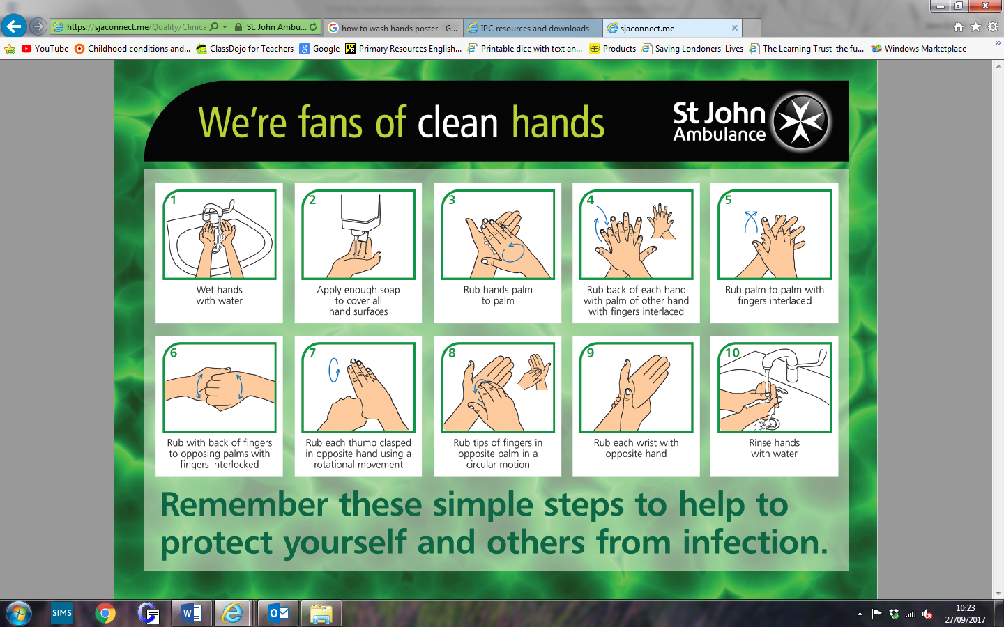

# Addendum for Covid-19 Protocols

Covid-19 can be contracted through exposers to large respiratory droplets and vomit. This addendum is to be read alongside the ongoing risk assessments and current government guidance.

* Coughing/sneezing onto mucous membranes (mouth/eyes)
* Needs close contact for this to occur (within one meter)

Contact with respiratory secretions

* Transfer by touching mucus membranes
* Tissues/surfaces contaminated with respiratory secretions

Symptoms of Covid-19

* Symptoms start 5-11 days after exposure
* Majority have fever and dry cough (rapid onset)
* Symptoms last 5-6 days
* Severe illness starts from day 7
  + With and increased shortness of breath and lung inflammation.

It is vitally important to maintain good hygiene. On arrival in the medical room, staff will undertake a thorough cleaning regime, cleaning all surfaces at the start of the break time and cleaning touched surfaces between casualties, and prior to leaving the medical room as per the training given.

Staff will follow the correct hand washing procedures displayed around school.

Gloves are an important barrier when providing first aid and staff should remember

* Good hand hygiene prior to donning
* To wear the correct size
* Single patient use only
* Only wear when required and NOT all the time.

Masks and additional PPE

* Should be well fitting and fit for purpose
* Staff should not touch the body of the mask once applied
* Worn with eye protection, if splashing of blood or body fluid, secretions or excretions onto the nose or mouth is likely.
* Are single use, is to be disposed of into clinical waste.
* Staff will follow the donning and doffing protocol as directed by signs in the medical room.

Temperature checking

Staff will continue to use the forehead strip for checking temperature (guidance only) they will clean it thoroughly and return to the correct storage place. No other types of thermometer should be used, unless purchased by the school, training given and item is calibrated appropriately.

Assisting with Personal Care

Staff will ensure they use appropriate PPE when assisting a child with self-care and dispose of this in clinical waste when doffing.

