HARRINGTON HILL PRIMARY SCHOOL

MARKING AND FEEDBACK POLICY

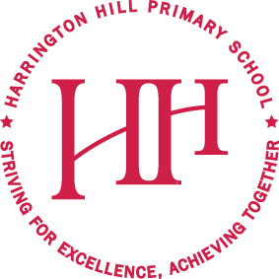

REVIEWED: September 2020

NEXT REVIEW DATE: July 2021

Striving for Excellence. Achieving Together.

Striving for excellence. Inspiring to achieve collaboratively through respect, happiness and creativity. We are independent and reflective for continuous improvement

What is the purpose of the policy?

The purpose of this policy is to make it explicit for all staff how teachers mark pupils’ work and provide feedback. All members of staff are expected to be familiar with the policy and to apply it consistently.

Why do we need a marking policy?

It is important to provide constructive feedback to children, focusing on success and improvement needs against learning intentions. Feedback should be a focal point at the beginning of each lesson, when pupils should all check and respond to feedback from the previous day. This enables children to become reflective learners and helps them to close the gap between what they can currently do and what we would like them to be able to do. Feedback should enable thinking and promote depth within the learning intention.

What are the principles that guide the school’s approach to marking?

Marking needs to be meaningful and used constructively to promote pupils’ learning, offering each child challenge and motivation. It is a valuable tool in the learning and assessment process.
Feedback should:

- be manageable for teachers and accessible to children;
- relate to the learning intention;
- involve all adults working with the children in the classroom;
- give recognition and praise for achievement and clear strategies for improvement;
- allow specific time for children to read, reflect and respond to marking in green pen;
- inform future planning and group target setting;
- use consistent codes across the school;
- ultimately be seen by children as a positive approach to improving their learning;
- catch and intervene with misconceptions at the point of learning (as often as possible).

What marking looks like at Harrington Hill?

It is expected that:
- All work is to be marked by the teacher or teaching assistant. Work is initialled if another adult, who is not the class teacher, marks it. All books must be marked before the next lesson in that subject.
- Where comments are made, they move learning on.
- Marking always corrects or addresses basic skills, e.g. handwriting and/or basic punctuation errors.
- Teachers mark work using the symbols in the Marking Code.
- If a child gets a question wrong in maths, a dot needs to be used and not a cross. Children should show their corrections next to the dot using green pen.
- English: children should respond to ‘think pinks’ in green pen at the start of the lesson. Children are also given an individual green pen improvement point fortnightly based on teacher judgement. If it is at the end of the unit, this will be addressed in an improvement session.
- Marking will be done in red pen.
- Pupils’ own marking for improvement or peer marking will be done in green.
- Pupils will self-assess each piece of work in green pen using the appropriate shape symbol.
- Teacher’s handwriting must be clear and legible and following the joins of the handwriting policy.
- A maximum of 3 misspelled words will be indicated using the marking code modelled in the margin and children will practise below.

TEACHER & PUPIL ASSESSMENT SYMBOLS

Child has/ I have understood and achieved the Learning Intention

Child has/ I have understood the Learning Intention but need more practise

Child does not/ I do not understand the Learning Intention

Marking Codes:

Spelling mistake sp highlight the misspelt word in pink. Then show the
correct spelling in the margin.

Omission of letter/word/phrase ^

New paragraph needed //

Missing punctuation Teachers will draw a red circle/ pink line to indicate

Independent pupil work T to write ‘I’ next to the assessment symbol

Support given W/S (from TA/teacher) written next to the assessment symbol

Supply Supply

Shared writing SW

Guided writing GW

Indication of a section to improve * * OR [ ]

Great Green and Think Pink for in depth marking in English:
Improvement sessions begin when we sit down to mark. The quality of the next step target that we give pupils dictates the success of the lesson the next day. The next step will be personalised to the child.
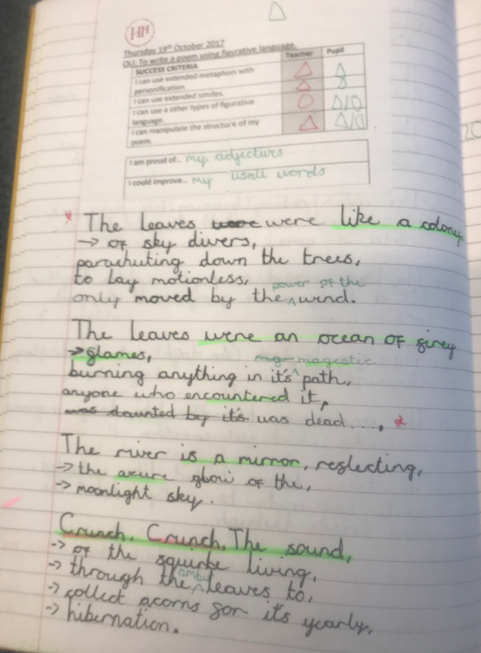
Great green and think pink is to be used at a minimum fortnightly for the in depth mark. Teachers will highlight the great things they see in the children’s writing in green and highlight the things they want the children to think about in pink.

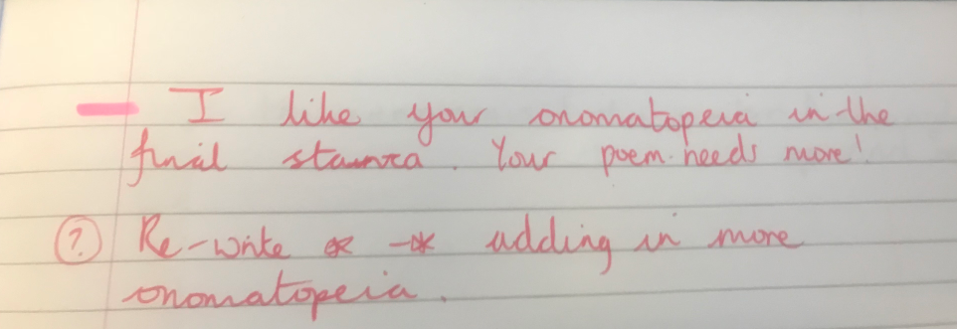
Pink line used to identify next step.

Maths Marking:

The children should respond daily to a green pen question or correct yesterday’s mistakes in green pen. Please see below for examples of maths marking at Harrington Hill:

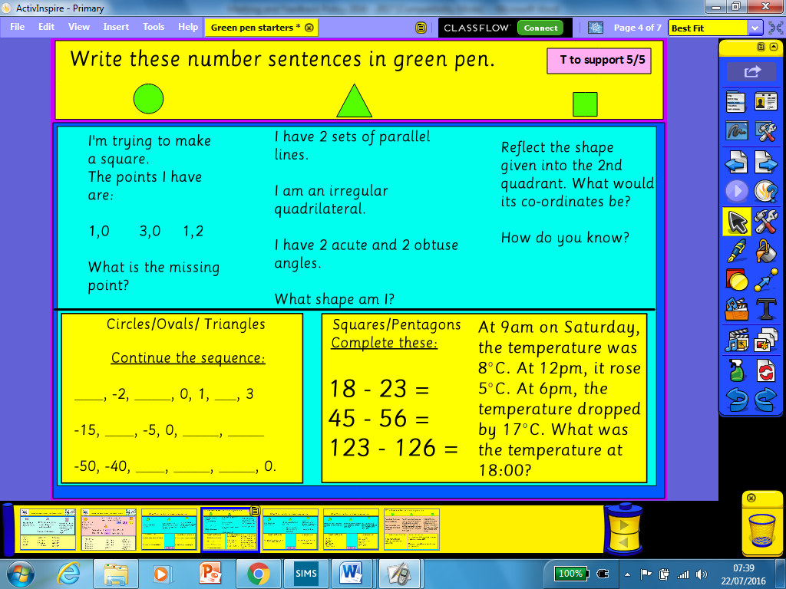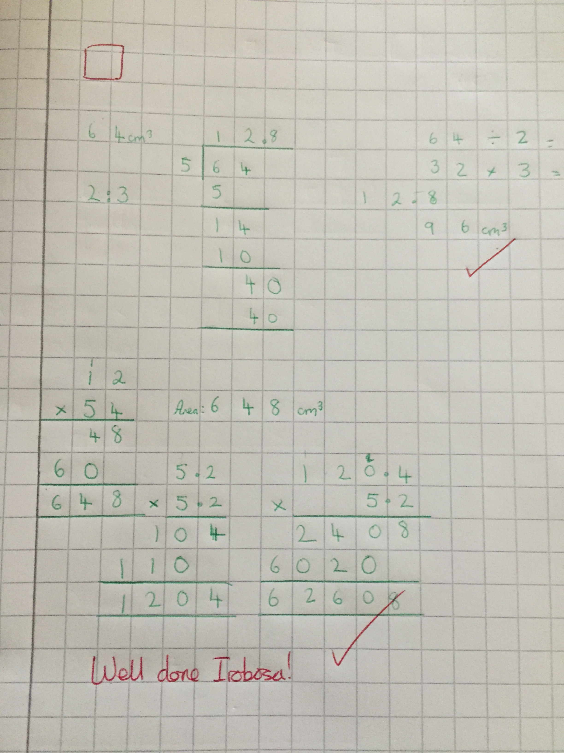

Science and Topic Marking:

The knowledge harvest should be added to in green pen each lesson.

INSERT PICTURES

Children must respond to a green pen question twice per half term.

